**Maiza Falcon Rojas**

**February 20, 2024**

**Assignment: Activity 4 - File I/O and Exception Handling**

**Class: CST-239**

GitHub link: https://github.com/maiza02/Activity-4.git

Loom Link:

**Part 1A**

Figure 1: Screenshot of Output for Part 1A

Figure 2: Screenshot of Text File InUsers of the 5 user records

Figure 3: Screenshot of Updated File After running program

Figure 4: Screenshot of Output with Updated Code to a Non existing file name

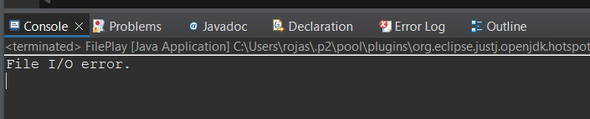

Figure 5: Screenshot of exception stack trace



**Part 1B**

Figure 6: Screenshot of Output with updated code

Figure 7: Screenshot of text file copied into the OutUser text file I changed the order so you can tell the differences between part a and b.

**Part 1C**

Figure 8: Output Console with updated code

Figure 9: Screenshot of Text filed after running program

**Part 1D**

Figure 10: Screenshot of Console with updated code

Figure 11: Screenshot of text file after updated code I again switched the names around so you can see it the difference.

**Part 2**

Figure 12: Screenshot of console after running the code

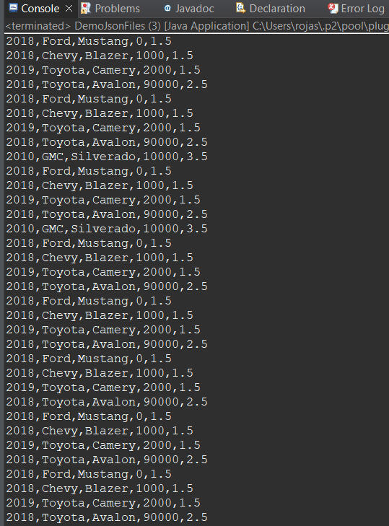

Figure 13: Screenshot of out.json file after running the code

**Follow up Questions:**

**What was challenging?**

What I found challenging was adding all the .jar files to the code. For some reason, eclipse was not reading the files correctly so I had to fix some things so it could work.

**What did you learn?**

I learned how to add .jar files to my code and how to fix Eclipse if it is not reading the files correctly.

**How would you improve on the project?**

I feel like part one did not have to be broken into parts, more specifically the code could have been all in the same project just updating the code. There as been similar activities that just updated the code so I do not see why we had to make separate projects for each part.

**How can you use what you learned on the job?**

Reading and using JSON files, along with serialization and deserialization, would be valuable in roles involving web development, API integrations, or any scenario where structured data exchange in JSON format is prevalent.